The LASI High-Resolution Subsurface Imaging System

The Laboratory for Advanced Subsurface Imaging (LASI) high-resolution subsurface imaging system transmits electromagnetic fields in order to probe the earth. The depth of penetration is determined by the frequency of the electromagnetic fields and the spacing between the transmitter and receiver. This system has been optimized to probe the relatively shallow depths (1-30 m) encountered in many environmental, engineering, and mineral-resource investigations. From the received electromagnetic fields, the electrical resistivity (and dielectric constant at high frequencies) are determined at various depths along a profile line. A cross section displaying resistivity (or dielectric constant) may be interpreted in terms of buried objects, fluid content, or varying lithology.

The technology used in the LASI high-resolution subsurface imaging system has evolved over a period of approximately 10 years. Support for this development has included: Electric Power Research Institute, Copper Research Center, U.S. Geological Survey, U.S. Bureau of Mines, Department of Energy, U.S. Army, and University of Arizona. The system developments have been concentrated primarily in three frequency ranges: Low Frequency or LF - 30 Hz to 30 kHz; Medium Frequency or MF - 1 kHz to 1MHz; and High Frequency or HF - 30 kHz to 30 MHz.

Each frequency range in the LASI high-resolution subsurface imaging system has some components which are specific to that frequency range (such as different receiving and transmitting coils). Each application also has some specific components (such as more powerful power amplifiers for greater depth of penetration). All the frequency ranges have a number of important common features which have been developed over the course of the entire development and provide a unique capability for high-resolution subsurface imaging. Some of these unique features include: (1) a simultaneous calibration procedure which allows very-high-accuracy measurements; (2) wide-bandwidth, high-sensitivity, magnetic-field-sensing coils; (3) three-dimensional data acquisition and processing of the recorded magnetic fields; (4) computer control and automation for very rapid surveying to allow dense spatial sampling over a broad area; (5) elimination of electric-field interference at high frequencies; (6) rapid neural network interpretation at the field site; and (7) visualization of complex structures during the survey.

Development of this high-frequency electromagnetic sounding system represents a significant technological breakthrough in electromagnetic geophysics. There are no other systems currently available which offer the same combination of rapid surveying, very-high-accuracy measurements, and wide-bandwidth recording (including the capability to record both low-frequency conduction-current and high-frequency displacement-current effects).

This system provides the potential for much greater depth of penetration than Ground Penetrating Radar (GPR) in highly conductive soils. It also provides wider bandwidth along with rapid surveying than conventional electromagnetic (EM) systems. In particular, it provides both low-frequency data from which the electrical resistivity of the subsurface can be interpreted and high-frequency data from which the dielectric constant of the subsurface can be interpreted. Some targets of interest in near-surface investigations may appear predominantly in the electrical-resistivity cross-sections (for example, metallic targets, inorganic contaminants, or lithology variations) and other targets may show up predominantly in the dielectric-constant cross sections (for example, organic contaminants or non-conducting targets such as voids).

In the following pages, we show examples of applications of this technology. The examples include use of the LF, MF, and HF technology. Although each technology was developed through specific funding sources for specific problems, the complete set of technologies and frequency ranges are applicable to a wide set of problems encountered by government and private industries, including environmental site characterization and long-term monitoring, engineering studies, and mineral exploration.

Our demonstration surveys have shown that this system is a significant advance in the state-of-the-art for high-resolution subsurface imaging. We have successfully mapped features with greater spatial and depth resolution than conventional EM techniques.

The system developed here currently exists in prototype form. Although the prototype is a moderately-large, research-oriented system, it is very flexible and is particularly suitable for optimization at specific field sites. Our current objective is to continue development of this technology as well as obtain a more diverse set of case histories which demonstrate the system's capabilities. After additional field demonstrations are conducted, we expect that this technology will be adapted to a lightweight, portable system which can be operated by relatively inexperienced field crews.

For further information on the LASI high-resolution subsurface imaging system, contact:
Dr. Ben K. Sternberg
Laboratory for Advanced Subsurface Imaging (LASI)
Dept. of Mining and Geological Engineering
University of Arizona
Tucson, AZ 85721-0012
TEL #520-621-2439
FAX #520-621-8330
bkslasi@u.arizona.edu
Mapping Buried Waste
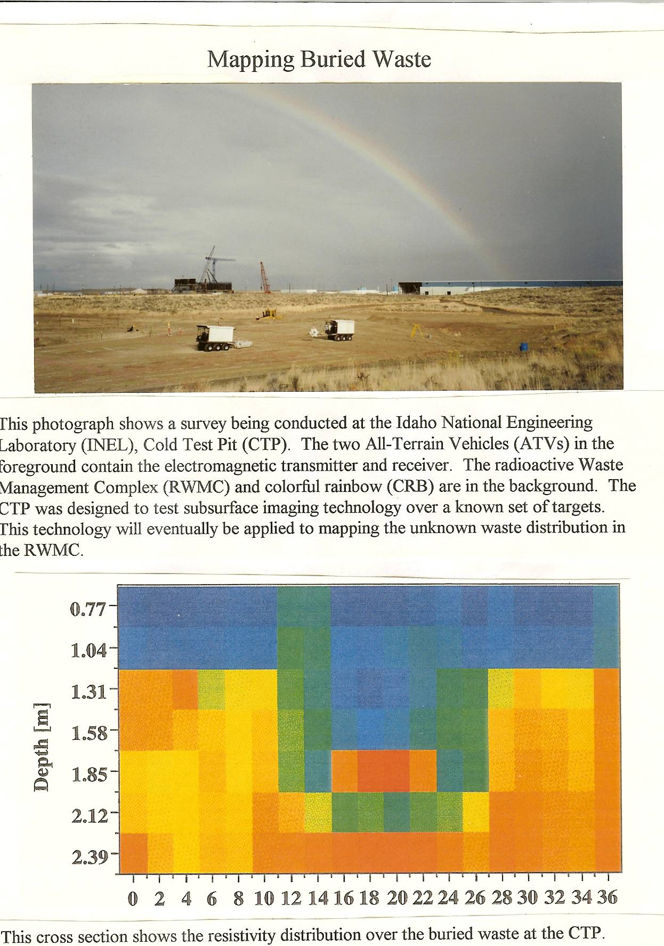
This photograph shows a survey being conducted at the Idaho National Engineering Laboratory (INEL), Cold Test Pit (CTP). The two All-Terrain Vehicles (ATVs) in the foreground contain the electromagnetic transmitter and receiver. The radioactive Waste Management Complex (RWMC) and colorful rainbow (CRB) are in the background. The CTP was designed to test subsurface imaging technology over a known set of targets. This technology will eventually be applied to mapping the unknown waste distribution in the RWMC.
This cross section shows the resistivity distribution over the buried waste at the CTP. These data were collected with the HF system and a coil separation of 8 m. The color scale is related to the electrical resistivity of the ground. The horizontal scale is profile distance in meters. The changes in electrical resistivity outline the edges of the buried waste very accurately. This subsurface image also shows the thickness of the overlying clay cap. Furthermore, variations of the electrical resistivity correlate with different types of waste within the pit.
Mapping a Plume of Underground Fluid
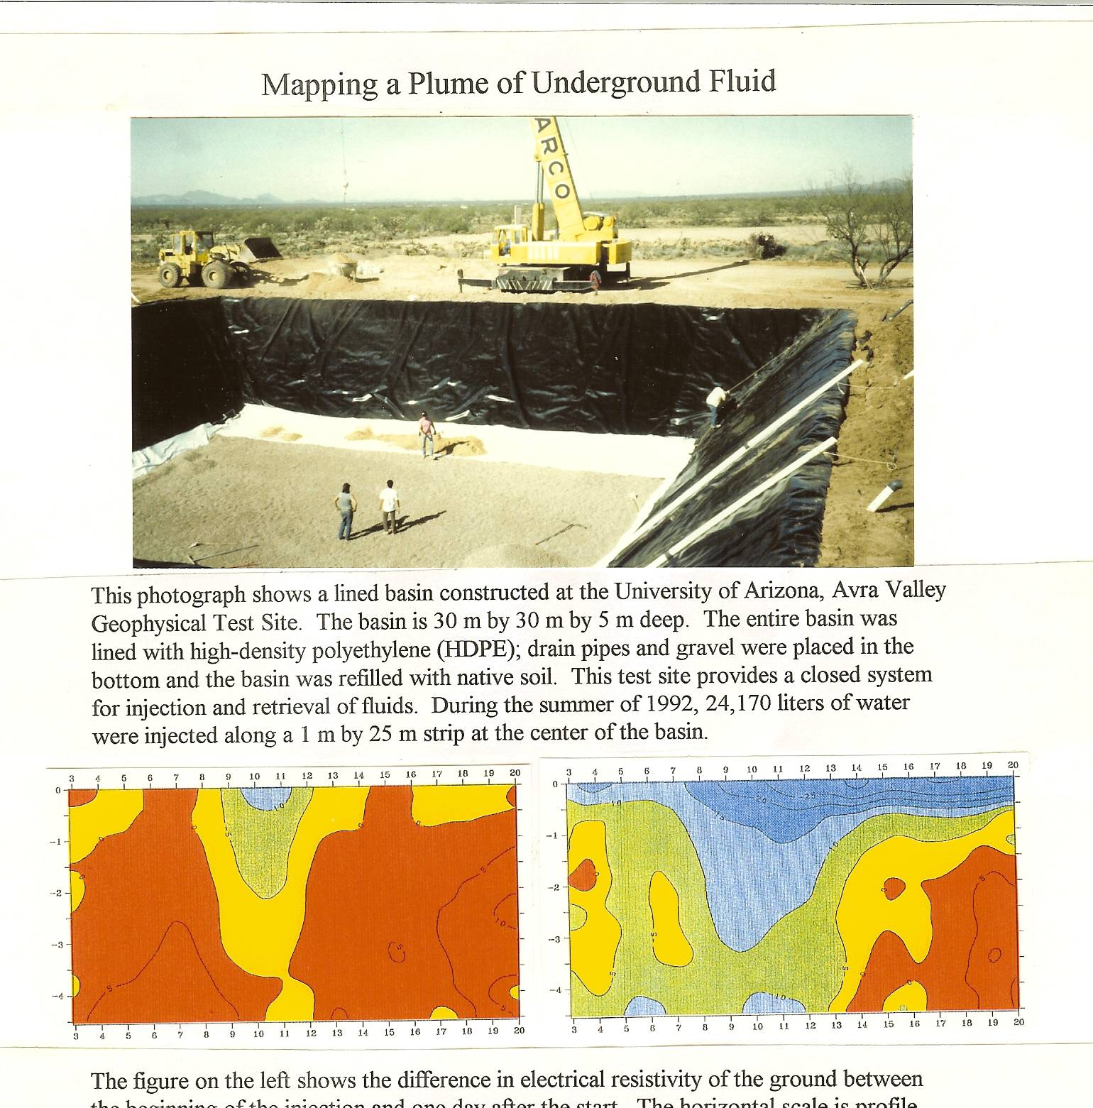
This photograph shows a lined basin constructed at the University of Arizona, Avra Valley Geophysical Test Site. The basin is 30 m by 30 m by 5 m deep. The entire basin was lined with high-density polyethylene (HDPE); drain pipes and gravel were placed in the bottom and the basin was refilled with native soil. This test site provides a closed system for injection and retrieval of fluids. During the summer of 1992, 24,170 liters of water were injected along a 1 m by 25 m strip at the center of the basin.
The figure on the left shows the difference in electrical resistivity of the ground between the beginning of the injection and one day after the start. The horizontal scale is profile distance in meters. The vertical scale is depth in meters. The small blue region (more negative than -10 ohm-m) shows the location of the plume of injected water. These data were collected with the LF system. A long-line source was oriented parallel and offset 10 m from the injection region. The receiver line was perpendicular to the line source and the injection region. The figure on the right shows the difference in electrical resistivity of the ground between the beginning of the injection and 17 days after the start of the injection. The blue area (more negative than -10 ohm-m) has increased in depth and spread out. There was a very close correspondence between these images of the fluid location determined from the surface measurements and images based on 25 electric well-log and neutron probe measurements located in the center of the basin. The high-accuracy calibration method used in the ellipticity system makes it possible to accurately map the flow of fluids over a long period of time.

Mapping Disturbed Ground
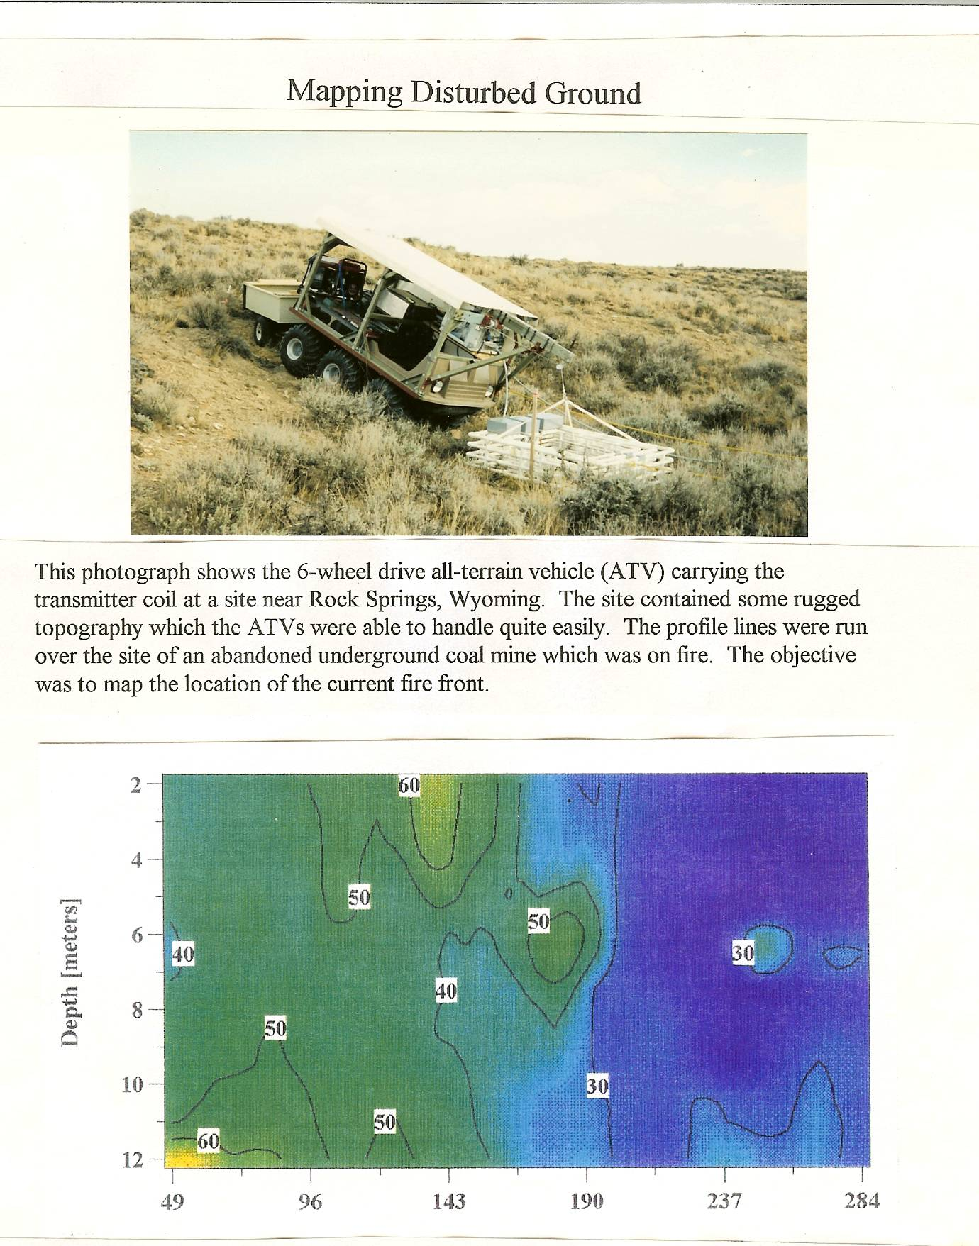
This photograph shows the 6-wheel drive all-terrain vehicle (ATV) carrying the transmitter coil at a site near Rock Springs, Wyoming. The site contained some rugged topography which the ATVs were able to handle quite easily. The profile lines were run over the site of an abandoned underground coal mine which was on fire. The objective was to map the location of the current fire front.
This figure shows one of the cross sections of electrical resistivity versus depth. The horizontal scale is profile distance in meters. These data were collected with the MF system and a coil spacing of 32 m. The low resistivities on the right of this figure are interpreted to be due to disturbed ground caused by the underground fire. The interpreted disturbed zone on this subsurface image as well as adjacent profile lines were used to produce a map of the fire front which was in excellent agreement in those areas where the fire front was known from independent information.

Mapping Tunnels
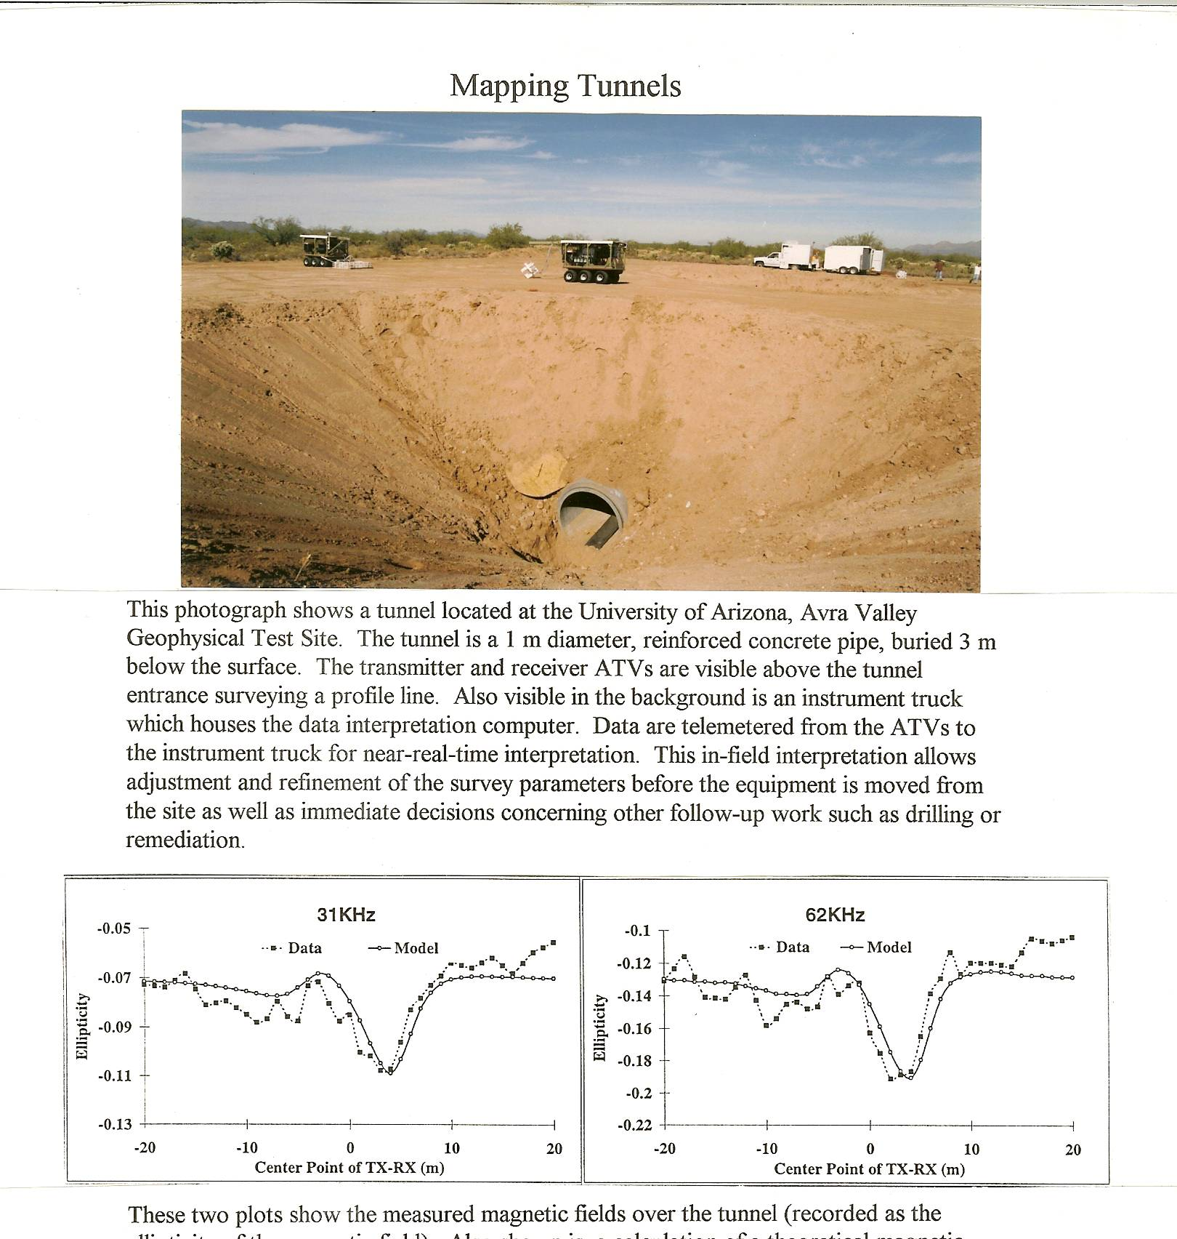
This photograph shows a tunnel located at the University of Arizona, Avra Valley Geophysical Test Site. The tunnel is a 1 m diameter, reinforced concrete pipe, buried 3 m below the surface. The transmitter and receiver ATVs are visible above the tunnel entrance surveying a profile line. Also visible in the background is an instrument truck which houses the data interpretation computer. Data are telemetered from the ATVs to the instrument truck for near-real-time interpretation. This in-field interpretation allows adjustment and refinement of the survey parameters before the equipment is moved from the site as well as immediate decisions concerning other follow-up work such as drilling or remediation.
These two plots show the measured magnetic fields over the tunnel (recorded as the ellipticity of the magnetic field). Also shown is a calculation of a theoretical magnetic field ellipticity curve for the known tunnel location and size. There is a good match between the theoretical and measured curves. The theoretical curve is sensitive to the location and depth of the tunnel and these parameters are therefore well determined by these data. This system was also used over a tunnel at the Nevada Test Site (NTS). This tunnel was at a depth of 30 meters. Again the LASI high-resolution subsurface imaging system detected the tunnel and determined its location and depth. Both the MF and the HF systems were used at the Avra survey with a coil separation of 9 m. The MF system was used at NTS with a coil separation of 90 m.

Mapping Contaminated Soils
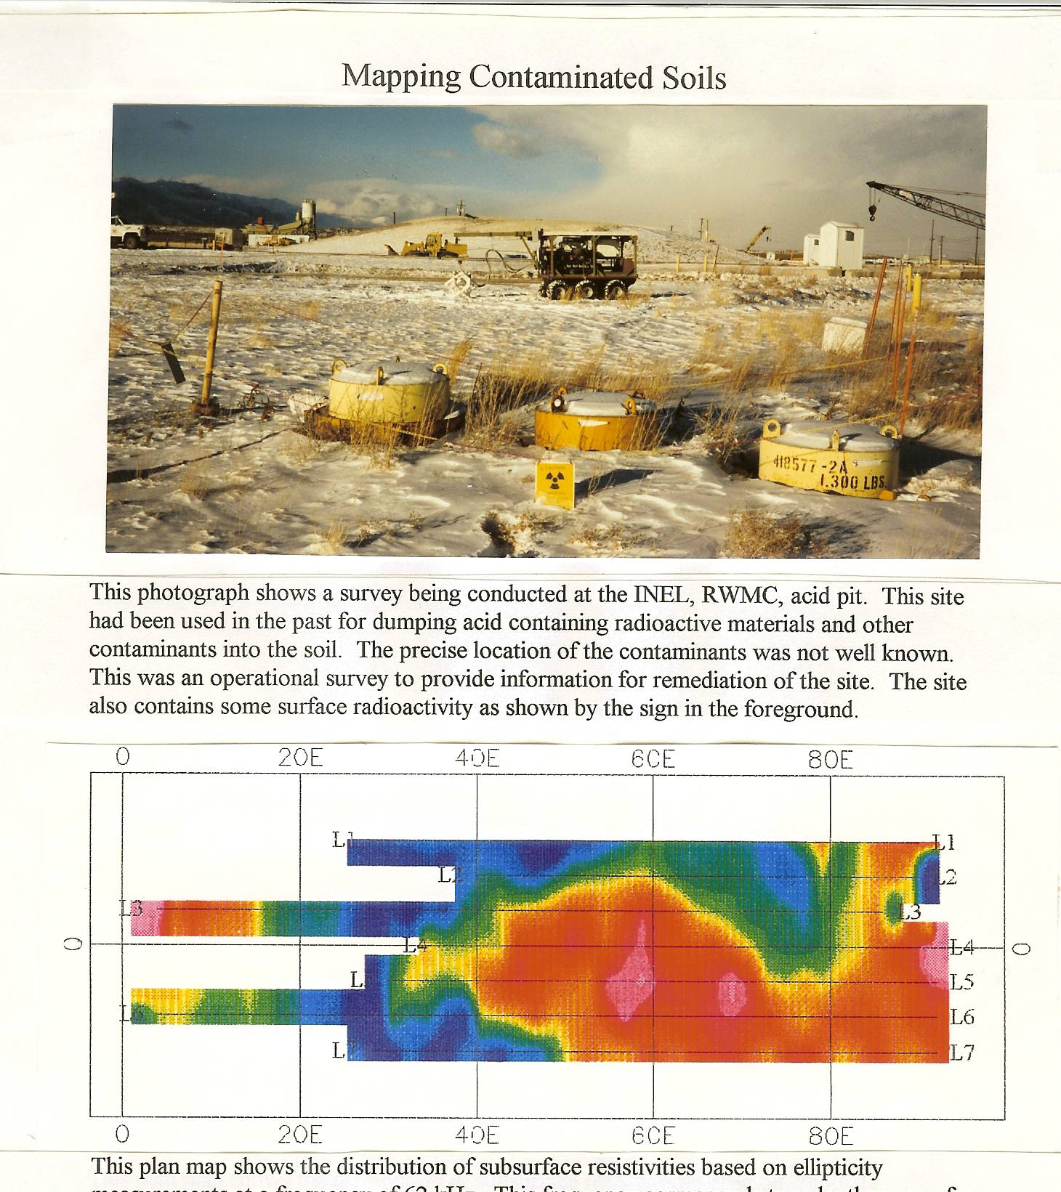
This photograph shows a survey being conducted at the INEL, RWMC, acid pit. This site had been used in the past for dumping acid containing radioactive materials and other contaminants into the soil. The precise location of the contaminants was not well known. This was an operational survey to provide information for remediation of the site. The site also contains some surface radioactivity as shown by the sign in the foreground.
This plan map shows the distribution of subsurface resistivities based on ellipticity measurements at a frequency of 62 kHz. This frequency corresponds to a depth range of approximately 2-to-2.5 meters. These data were collected with the HF system at a coil spacing of 8 m. The red color (which corresponds to low electrical resistivities, of the order of 25 ohm-m) in the center of the map shows the location of the most heavily contaminated soil. The blue color (of the order of 40 ohm-m) shows background soil response. The red color on the far left of the map shows the location of solid waste in an adjacent disposal cell. The red color on the far right shows the location of buried utilities beneath a road. Other frequencies were used to map the concentration of contaminants at various depths. This survey provided much more detailed information on contaminant location than previous electromagnetic (EM) conductivity surveys at this site. The soils at this site are too conductive for ground penetrating radar (GPR) to be effective. The LASI EM systems can provide high-resolution subsurface maps in a wide variety of circumstances where other conventional methods are too limited.

