GenMon v2.0

ARBITRARY WAVEFORM GENERATION AND MONITORING SOFTWARE FOR USE WITH THE LAYLA 24/96 SOUND SYSTEM BY
ECHO DIGITAL AUDIO

User’s MANUAL
4/17/2004

PREPARED BY TERRY LEACH
CONTRACT PROGRAMMER UNDER

DR. BEN STERNBERG
DEPARTMENT OF MINING AND GEOLOGICAL ENGINEERING
UNIVERSITY OF ARIZONA

SYSTEM OVERVIEW 1
SOFTWARE OPERATION OVERVIEW 2
Sound System Control 3
Clock Rate Control 3
Dynamic or Static Channel operation 3
Sound Buffer Size affects real time performance 4
Sample Size controls FFT resolution 4
Choosing synchronized or streamed waveforms 4

Waveform Component Definition 6
Activating/Deactivating a single waveform component 6
Selecting D/A channels 6
Setting component frequency 7
Functional form of waveform component 7
Controlling component magnitude and phase 7

Measurement Definition 8
Choosing measurement channels 8
Selecting measurement frequency 8
Selecting real time display 8
Selecting display (and file storage) measurement units 9
Controlling FFT size via down sampling 9

File Control 10
Interpreting File contents 11

Program Control 12

SYSTEM OVERVIEW

This manual discusses the use of the GenMon v2.0 software. The GenMon software was written to support arbitrary waveform generation and monitoring on up to 8 channels. In its current version the software supports arbitrary linear combinations of sine, square, saw-tooth, and triangular components to create waveforms on up to 8 channels. The software also allows for synchronized data acquisition on these channels. Acquired waveforms can be displayed in the time or frequency domain in real-time. FFT bin extraction and logging is also possible. The software will operate in conjunction with the Layla24’s external clocking capabilities ranging from 30kHz to 96kHz.

If you wish to work at frequencies below 10hz, a specially modified Layla 24 sound box is available from ECHO digital audio.

The GenMon software drives the Layla 24 sound box, available from ECHO digital audio. Prior to running the software, the Layla 24 should be powered on and externally clocked at one of the supported frequencies. Alternatively, you can make use of the Layla’s internal clock. In either case choosing and configuring clocking options is performed from ECHO’s configuration software.

From a software standpoint, there are several elements which interact in real time. The first is the ECHO configuration panel (supplied by ECHO AUDIO corporation). Changes made on this panel affect GenMon software operation. Next there is an ASIO compliant sound driver which handles low level I/O to the LAYLA. The GenMon software configures this driver for you, however it must be installed. Finally the GenMon software performs waveform generation, monitoring, as well as FFT bin extraction and logging.

In order to use the GenMon software, you must install the ASIO compliant driver available from ECHO digital Audio’s web site. Install LabView 6.1, and install the GenMon .vi set available in the GenMonVIs.zip file. For modification of the GenMon software, as well as details of internal operation, please see the programmer’s reference file.

SOFTWARE OPERATION OVERVIEW

The GenMon software has a single panel interface, which makes it easy to perform key operations. Other panels, such as FFT or real time waveform displays, will be activated as needed. GenMon’s main control panel is shown below.

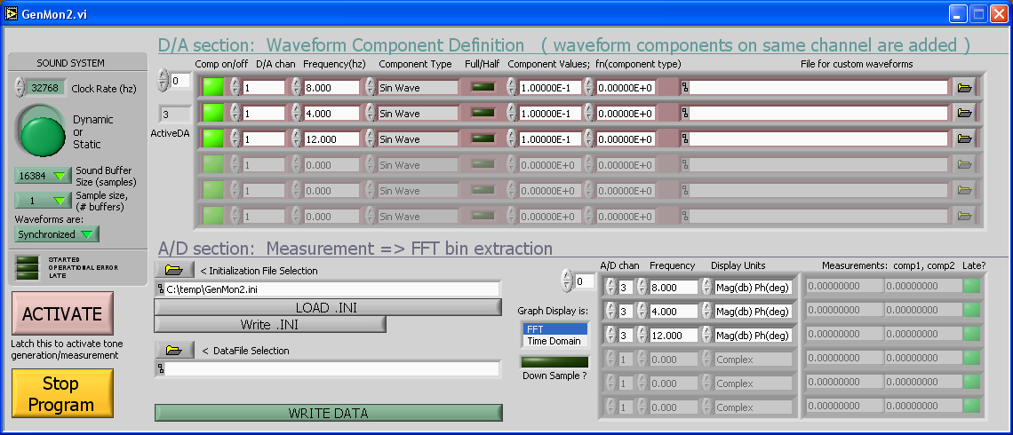

GenMon’s control panel has five main components. These are 1) sound system control, 2) waveform generation definition, 3) measurement definition, 4) File control, and 5) program control. The typical procedure is to define how the sound system will be used via the sound system control section, create waveform and measurement definitions and then save your entire configuration in an initialization file (.INI). This is followed by activating the sound system, and making waveform/measurement modifications as desired.

Upon start-up the GenMon software will load a default initialization file restoring all control settings from the prior GenMon session. You have the option of loading alternative initialization files in the file control section of the main panel.

Each of the user interface areas are described below.

Sound System Control

The sound system controls shown below are used to communicate to all software components how the sound system will be used and directly affect system real-time performance. Their main purpose is to configure the ASIO compliant driver.

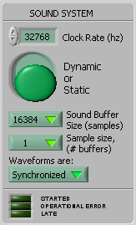

Clock Rate Control
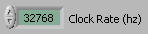The first control is the rate at which the sound system is being clocked. This is not really a control as it cannot directly affect the clock rate on the Layla. It is used to record the current external (or internal) clock rate. The clock rate “control” basically affects FFT extraction and results display.

Dynamic or Static Channel operation
The second control lets you operate the sound system dynamically or statically. Running the sound system in Dynamic mode means that all 8 channels of A/D and D/A will be allocated and serviced once the sound system starts running. This option is only practical when you are using synchronized, as opposed to streamed waveforms, and low sample sizes. It’s advantage is dynamic use of all sound system channels, it’s price is that under many desired operating conditions, the software will not be able to keep up with the Layla hardware.

The “Static” option means only those D/A and A/D channels appearing in the waveform and measurement definitions will be activated. You will not be able to change channels while the system is running. Next you must select the sound buffer size. The sound buffer size determines how frequently the ASIO sound driver thread will call the GenMon software for new sound buffer information.
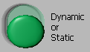

Sound Buffer Size affects real time performance
You must select one of the supported sound buffer sizes, the maximum being 16384 samples per ½ buffer. This control allows you to trade off throughput efficiency with speed of channel access. At a clock rate of 32768hz, a 16384 sound buffer can take up to 1 second before changes in your waveform will take effect (remember it’s a double buffer). At the same time, this involves the least number of calls to the ASIO.vi and minimizes the calls the sound driver thread must make to bufSW which is embedded in ASIO.vi of the GenMon software.
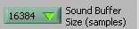

Sample Size controls FFT resolution
The next control lets you select the Sample size in units of sound buffers. For example a sample size of 4 and a sound buffer size of 16384 means that all sampled waveforms and FFT calculations will involve 4*16384 or 65536 points. Your trade off here is once again one of performance. FFT’s have a time complexity of n*ln(n) and for larger sample sizes will take enough time that the software won’t keep up with the Layla hardware. Since this performance varies from machine to machine, the best way to determine your operating limits is via trial and error.

Choosing synchronized or streamed waveforms
The final control affects how waveforms are handled during generation and subsequent transmission. Static waveforms fill a sound buffer “exactly”. All sound buffers are always filled to capacity because the sound driver interface has no mechanism for handling partial sound buffers, so what is the meaning of “exactly”. Given an N point sound buffer, and the value of the sample to be output on the D/A as Wave(N), then “exactly” means Wave(1) = Wave(N+1). Meaning that each waveform on each active channel must repeat itself without any
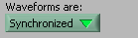
discontinuous breaks. In other words once the sound buffer has been loaded, it need not be changed unless the waveform definition changes. Streamed waveforms need not be exact (although nothing precludes Wave(1) = Wave(m*N+1)) and require a sound buffer update each time the sound driver thread calls the embedded bufSW function. Streamed waveforms require that the software perform all of its processing fast enough to stay synchronized with the Layla hardware.

Waveform Component Definition

The waveform controls shown below define linear combinations of waveform components on one or more D/A channels. Complex waveforms may be built from multiple component definitions on a given channel. These controls will determine which D/A channels are activated and serviced once the sound system is started via the “Activate” button. The exception to this occurs when you have set the sound system controls to “Dynamic” as described in the prior section, in which case ALL D/A channels are activated independent of waveform control settings. Running in “Dynamic” mode you are free to define waveforms on any channel at any time.

These controls are a scrolling table, for all practical purposes you may define an unlimited number of components, subject only to available machine memory. The box in the upper left corner selects and indicates the row number displayed as the first row in the table.. The box just below this indicates the total number of component definitions in the table.

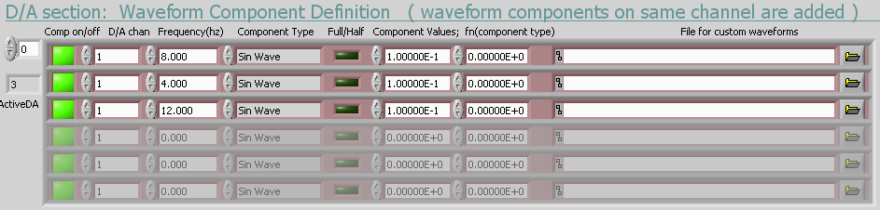

Activating/Deactivating a single waveform component
Within the table, the first control is the active indicator which is either green or red. When green it indicates that the component will be included in the waveform for that D/A channel. This control lets you select a sub-set of the currently defined waveform components on any given channel.

Selecting D/A channels
The control immediately to the right selects the D/A channel for transmission. The Layla has 8 D/A channels, numbered from 1 to 8. Multiple components on the same channel will be added.

Setting component frequency
The frequency of transmission is next. While you may enter any desired real number in this box, note that some frequencies may not make sense given the configuration of the sound system. If you have your graphical display set to “FFT” such components will be immediately obvious. For example a sound buffer size of 16384, clock rate of 65536, sample size of 1, and synchronized waveforms, frequencies which are not a multiple of 4hz cannot be implemented. To be sure the system will calculate a 3hz sine wave for example, but it is not possible to fit an integral number of waveforms into 16384 points at the given clock rate, so when the next sound buffer is requested by the sound driver thread there will be a discontinuity, making your transmitted waveform something other than a 3hz sine wave. The easiest way to achieve a 3hz waveform given the above parameters would be to select “Streaming” waveforms as opposed to “Synchronized”. With this parameter selection, a new sound buffer is computed and sent to the driver at each request for a new buffer. No discontinuities occur.

Functional form of waveform component
The next control selects the functional form for waveform generation. Choices of Sine, Triangular, Square, and Saw Tooth have been implemented. Other choices have been allowed for but not yet implemented, if selected, they will default to Sine wave generation.

The next control “Full/Half” is not yet implemented.

Controlling component magnitude and phase
The next pair of controls, defines the magnitude and phase of the transmitted waveform via a complex number pair. The number on the left is the real component.

The final control is not yet implemented, and will allow selection of a file containing a stream of binary bit patterns to be sent to the sound system.

Measurement Definition

Like the waveform definition control, the measurement definition control is a scrolling table whose upper left corner box selects the top row to be displayed in the table. Within the table, the leftmost control selects the A/D channel on which to acquire a waveform. Next is the frequency to be extracted from the FFT of that channel’s waveform. Next is a selection of units for display of the extracted bin. The next two values are derived from the extracted FFT bin. The last component is a late flag indicating if the GenMon software got behind in collecting measured waveforms from the sound driver thread. This control will be red each time a measurement is late. Red indicates that at least 1 sound buffer was lost in the waveform measurement.

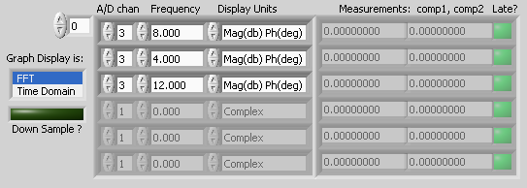

Choosing measurement channels
These controls define the A/D channels to take measurements from. To take multiple measurements on a given A/D channel, make an entry for each frequency you want extracted from the FFT.

Selecting measurement frequency
Enter the frequency you would like to extract from the FFT of the measured waveform on the desired A/D channel. As shown below, 3 measurements are being made on channel 3.

Selecting real time display
Also, included in this control set, is selection of type of real time display. Each active A/D channel will have an associated real-time display. You can choose FFT or time domain waveform display, or you can turn all real-time displays off. When generating streamed waveforms, or calculating large FFT’s, you may not want to pay the time overhead of the real time displays. These can be shut off by holding the shift key while clicking the active real-time display/s off.

Selecting display (and file storage) measurement units
You can choose to have your measurements displayed as a Magnitude (0-1 full scale) / Phase (degrees) pair. Alternatively Magnitude can be displayed in decibles (down from full scale), and Phase may displayed in radians. A real-imaginary pair format is also available. Note that whatever display units you choose will be the units associated with stored data.

Controlling FFT size via down sampling
The down sample button assures that no matter how many points have been collected in your measured waveform, a maximum of 65536 points will be sent to the FFT calculation. This data reduction is achieved through down sampling and is only effective if initial FFT’s indicate there are no high frequency components which will be aliased. Future development may include re-sampling of an FIR filter output prior to FFT calculation. The rate of down sampling is determined by the ratio of your acquired waveform size divided by 65536.

File Control

The file controls allow you to load and save the settings and values of all GenMon controls. They also allow logging of data collected and displayed in the measurement control section.

Upon program start up, the software will automatically load the GenMon.INI configuration file. On program exit, it will ask the user if GenMon.INI should be updated to reflect the most recent operating parameters of the software. Once the program is started, the user is free to load/save initialization files one or more times.

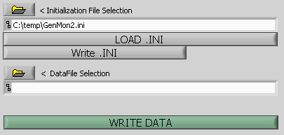

To log data, a data file name is first entered or browsed for. A block of data will be written to the file each time the “Write Data” button is pressed. All active rows in the measurement definition table will be written to the file. There are two additional control components (currently hidden) which will allow a once per file comment and a once per data block comment.

The “Write Data” button may be pressed at any time whether or not the sound system is active.

Interpreting File contents

Shown below is an actual file segment gathered with the GenMon program. The first column contains the A/D channel a measurement was recorded on. The second column indicates the frequency of the measurement.

1 5000 0 3 -157.194624 -148.150519
2 5000 0 3 -147.989044 -96.675105
3 5000 0 0 1.622816E-9 -2.009299E-8
4 5000 0 0 1.305273E-8 2.182295E-8
5 5000 0 0 2.142301E-8 4.970269E-8
6 5000 0 0 2.791689E-8 -4.168484E-8
7 5000 0 0 -1.065470E-8 6.357188E-9
8 5000 0 0 -6.656848E-10 -6.786135E-9

The third column indicates if the measurement was late. A 1 indicates late, while a 0 indicates a timely measurement was made. A late measurement means that at least 1 sound buffer was lost prior to FFT calculation.

The forth column indicates the units associated with the 2 subsequent measurement columns. Units are numbered from 0 to N in a direct 1 to 1 correspondence with displayed unit choices on the measurement definition control.

Program Control

The program control section consists of making the sound system active/inactive and exiting the GenMon software. Once all control banks have been configured, latching the “Activate” button will start and run the sound system until this button is un-latched. Remember that you can configure all control banks by loading a .INI file of your choice using the file controls.

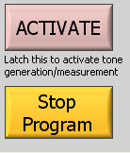

Once you have completed a data taking session, use the “Stop Program” button to exit the GenMon application. This button may be pressed whether or not the sound system is currently active. When pressed, the software will deactivate the sound system thread automatically, and ask the user for confirmation of an overwrite of the GenMon.INI file. The program will then exit closing all active application windows.

